
LIMITED LIABILITY COMPANY LASERWAR

SPECIFICATION

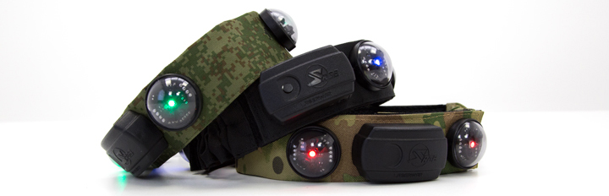

Smart RGB headband

7. Contact information
Official site:
www.laserwar.ru

Email:
info@laserwar.ru
support@laserwar.ru

Skype:
info-laserwar.ru
support-laserwar.ru



_____________________
stamp signature

Type of dressing with defeat sensors:

To connect 1 tagger

For connection of 2 taggers

2. Accumulators. As a power source in a wireless SMART RGB bandage, a lithium polymer battery of 1.8 Ah capacity is used. For its recharging, it is necessary to use only the universal auto-charger Li +.
First of all, you need to connect the charger to the device, and then - to the network.
The recharging process can be monitored using a special indicator on the charger. If the ac-accumulator is discharged - the LED lights red; At the end of the charging process, the color of the glow changes to green.
Attention! Recharge the dressing immediately after use under constant supervision at an ambient temperature of at least 0 ° C for no more than 180 minutes.

6. Warranty

The manufacturer guarantees the reliability of operation of the individual set of "LASERWAR" while observing the operating conditions by the consumer. The manufacturer undertakes to replace or repair the individual set of equipment free of charge, provided that the rules of transportation, storage, operation and payment for the delivery of faulty equipment to the city of Smolensk are followed by the consumer.
On the batteries, speakers, IR modules, the warranty is 14 DAYS.
ATTENTION! In the event of improper use of batteries (charging by an inappropriate type of charger), the battery warranty does not apply! With full technical guidance on the operation of laser tag equipment by LA-SERWAR, you can see on our website www.laserwar.ru.

6
7

Date of purchase:_______________

4. Description and work
4.1. Device
SMART RGB-bandage with impact sensors is a cloth tape with integrated electronics. The four sensors of the lesion are provided with a horizontal angle of 360 ° and a vertical angle of 180 °.
Control blocks are located in the side parts of the bandage. The device of the dressing with the sensors of the lesion is represented on the diagram:

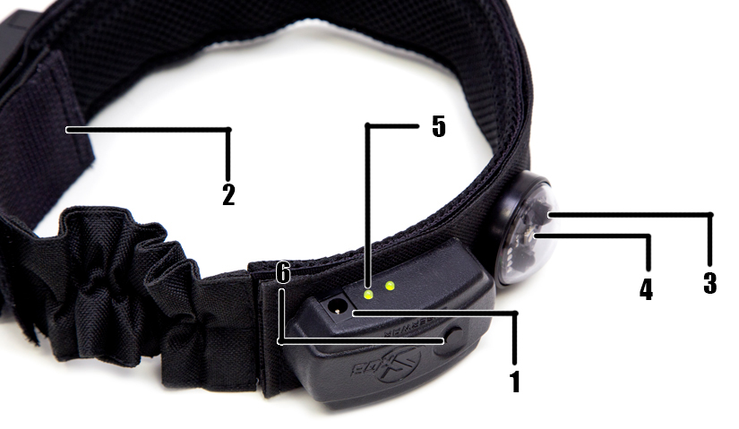
1. Power socket.
2. Hygienic cuff.
3. The TLWR LED.
4. TSOP sensors.
5. Charge indication.
6. Power button.
Information about the repairs carried out during the period of guaranteed service (to be filled in by the service center performing the warranty repair)

Date:__________________Completed work:  _____________________________________________________________________  Printing Service Center | Date:__________________  Completed work:  _____________________________________________________________________  Printing Service Center
Date:__________________Completed work:  _____________________________________________________________________  Printing Service Center | Date:__________________Completed work:  _____________________________________________________________________  Printing Service Center
Date:__________________Completed work:  _____________________________________________________________________  Printing Service Center | Date:__________________Completed work:  _____________________________________________________________________  Printing Service Center

3
10

4.2. Changing the settings of the game set

Change of tactical and technical characteristics for SMART RGB headbands with sensors of defeat is not provided.

4.3. Preparation for work

The wireless SMART RGB-dressing is activated by means of a clock button located on the control unit and connected via a Bluetooth channel to the tagger.
When using a dressing that supports simultaneous connection of two taigers, their connection occurs in sequence.

Activation of the game set is a remote control (the team "New Game") or "First Aid Kit". Once activated, the game kit is ready for use.

Terms of guarantee:

1. The guarantee becomes effective upon presenting the present coupon, which indicates the date of purchase of the equipment, confirmed by the service center.
2. These warranty obligations apply to products purchased only from an official representative of LLC LASERTAG, or its Official Dealer.
3. This warranty is void if defects in the product have occurred in the event of:
- non-observance of Instructions for use;
- mechanical damage;
- ingress of foreign objects, liquids, etc .;
- animal activities;
- unauthorized access to sites and details of persons who are not authorized to carry out specified actions;
- use of the product for purposes for which it is not provided;
- acts of force majeure (natural catastrophe, fire, accident, etc.);
- failure of the product due to improper connection, a faulty electrical outlet and / or poor maintenance of the product.
4. If the warranty card is lost, the duplicate does not issue.

4
9
5. Rules of operation

When using dressings, you should pay attention to the need for special hygiene cuffs that protect electronic components from moisture. If during the use of SMART RGB-dressing gets wet, it can lead to the failure of the electro-nick - the dressing should be dried immediately.
In addition, when using dressings, you may encounter mechanical damage to the covers that protect the sensors. In such cases, the covers must be replaced.
Store the equipment in a well-ventilated room at temperatures between + 18 ° C and + 30 ° C and relative humidity between 45 and 65%.
Store the equipment only in a charged state (at the rated voltage of the battery).
1. Weather conditions. We strongly advise against using the equipment in rain and temperatures below -20 ° C. Avoid moisture entering the sensors. If this happens - stop operation, pour the equipment at room temperature for at least 2 hours.
In no case can not immediately put on charge equipment, used at low temperatures. It is necessary to allow the electronics to warm up, to dry the condensate, which occurs when the weather conditions change sharply.

Dear Customer!
LASERTAG LLC welcomes you and thanks you for choosing our products, and also expresses confidence that the product you purchased will bring you pleasure and will last a long time. This coupon establishes a warranty liability for the product in the amount provided by the Law of the Russian Federation "On Protection of Consumer Rights".
This warranty card is valid for 12 months from the date of purchase of the product subject to the terms of the guarantee.

5
8
2
11
1. Purpose
SMART RGB-bandage with impact sensors is an integral part of the laser tag game set. It connects to the laser tag (tiger) via wireless bluetooth connection and serves to indicate the player's zone of defeat.

2. Technical specifications

 | Wireless
Weight | 0,220 kg
Battery type | Lithium polymer 1.8 ah
Charger type | Automatic, Li +
Battery life | Up to 48

- Delivery set

№  п/п | Name | unit of measurement | amount
1. | SMART RGB headband with defeat sensors | PC. | 1
2. | Hygienic cuff | PC. | 1
3. | Passport products | PC. | 1

